**Optimized Data Ingestion and Storage for Large-Scale Banking Data in PostgreSQL**

**Overview**

This document outlines the process of ingesting and optimizing the storage of a 1-million-row banking dataset into a partitioned PostgreSQL database. Key steps include dataset conversion, PostgreSQL setup, table partitioning, bulk data import, and performance optimizations.

**Environment Setup**

**Virtual Machine Configuration**

* **VMware**: Host virtualization platform.
* **Ubuntu**: Guest OS for database operations.
* **Dataset**: massive-bank-dataset-1-million-rows.xlsx stored on the VM.

PostgreSQL Installation:

*# Save as install-postgresql.sh*

*sudo apt install curl ca-certificates -y*

*sudo install -d /usr/share/postgresql-common/pgdg*

*sudo curl -o /usr/share/postgresql-common/pgdg/apt.postgresql.org.asc --fail https://www.postgresql.org/media/keys/ACCC4CF8.asc*

*. /etc/os-release*

*sudo sh -c "echo 'deb [signed-by=/usr/share/postgresql-common/pgdg/apt.postgresql.org.asc] https://apt.postgresql.org/pub/repos/apt $VERSION_CODENAME-pgdg main' > /etc/apt/sources.list.d/pgdg.list"*

*sudo apt update*

*sudo apt -y install postgresql*

**Execution**:

*chmod +x install-postgresql.sh*

*./install-postgresql.sh*

Database Initialization

*-- Access PostgreSQL*

*sudo -i -u postgres*

*psql*

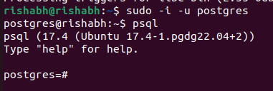

*-- Create database*

*CREATE DATABASE my_db;*

*\c my_db -- Connect to database*

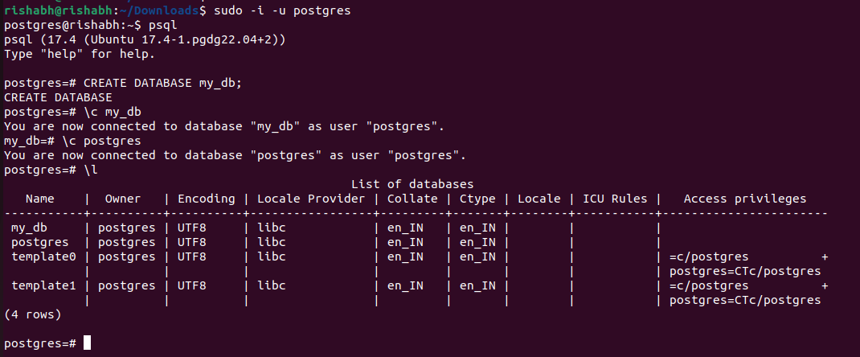

**Data Preparation**

**Excel-to-CSV Conversion**

Script: converter.py

*import pandas as pd*

*file = 'bankdataset.xlsx'*

*chunk_size = 100_000*

*header = pd.read_excel(file, nrows=0).columns*

*for i in range(0, 11): # 11 chunks for ~1M rows*

*df = pd.read_excel(*

*file,*

*skiprows=i * chunk_size,*

*nrows=chunk_size,*

*header=0,*

*parse_dates=['Date'],*

*dtype={'Domain': 'category', 'Location': 'category', 'Value': 'int32', 'Transaction_count': 'int32'}*

*)*

*if df.empty: break*

*df.to_csv(f'bank_data_part_{i}.csv', index=False, header=(i == 0))*

**Output:** 11 CSV files (bank_data_part_0.csv to bank_data_part_10.csv).

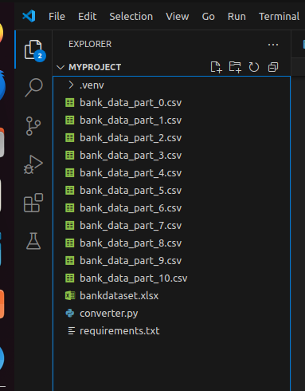

**Database Schema Design**

**Partitioned Table Structure**

*CREATE TABLE bank_transactions (*

*transaction_id SERIAL,*

*transaction_date DATE NOT NULL,*

*domain VARCHAR(20) NOT NULL,*

*location VARCHAR(50) NOT NULL,*

*value INTEGER NOT NULL,*

*transaction_count INTEGER NOT NULL*

*) PARTITION BY RANGE (transaction_date);*

**Monthly Partition Creation**

*DO $$*

*BEGIN*

*FOR month IN 1..12 LOOP*

*EXECUTE format(*

*'CREATE TABLE transactions_2022_%s PARTITION OF bank_transactions*

*FOR VALUES FROM (%L) TO (%L)',*

*LPAD(month::text, 2, '0'),*

*format('2022-%s-01', LPAD(month::text, 2, '0')),*

*CASE*

*WHEN month = 12 THEN '2023-01-01'*

*ELSE format('2022-%s-01', LPAD((month+1)::text, 2, '0'))*

*END*

*);*

*END LOOP;*

*END $$;*

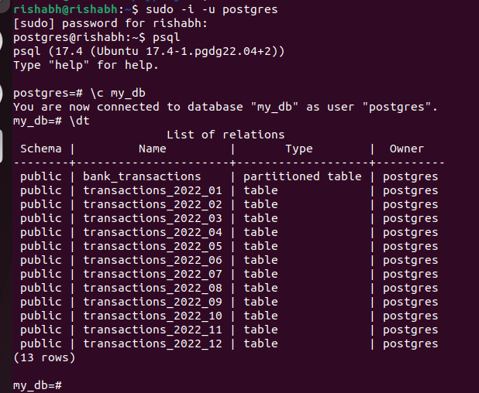

**Data Import**

**Disable Optimizations Temporarily**

* **Autovacuum:** Disabled to reduce overhead.
* **Indexes:** Not created during initial load to speed up writes.

**Bulk Import via COPY**

*for i in {0..9}; do*

*sudo -u postgres psql -d my_db -c "\COPY bank_transactions(transaction_date, domain, location, value, transaction_count) FROM 'bank_data_part_$i.csv' DELIMITER ',' CSV HEADER;"*

*done*

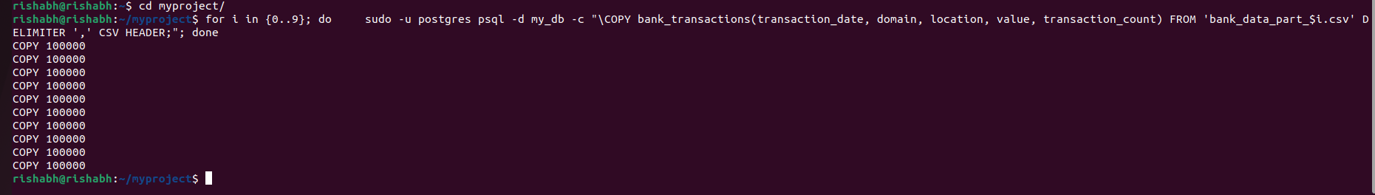

**Post-Ingestion Optimizations**

**ndexing Strategy**

*DO $$*

*DECLARE partition_name text;*

*BEGIN*

*FOR partition_name IN*

*SELECT inhrelid::regclass::text*

*FROM pg_inherits*

*WHERE inhparent = 'bank_transactions'::regclass*

*LOOP*

*EXECUTE format('CREATE INDEX ON %s (transaction_date)', partition_name);*

*EXECUTE format('CREATE INDEX ON %s (domain)', partition_name);*

*END LOOP;*

*END $$;*

**Storage Optimization**

**TOAST Compression:**

*ALTER TABLE bank_transactions*

*ALTER COLUMN location SET STORAGE MAIN; -- Compress values > 2KB*

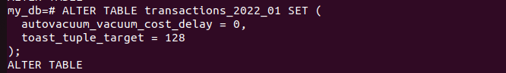

**Partition-Specific Settings:**

*ALTER TABLE transactions_2022_01 SET (*

*autovacuum_vacuum_cost_delay = 0,*

*toast_tuple_target = 128*

*);*

**Vacuum and Analyze**

*VACUUM ANALYZE bank_transactions;*



**Validation**

**Data Distribution Check**

*SELECT*

*tableoid::regclass AS partition,*

*COUNT(*) AS row_count,*

*MIN(transaction_date) AS first_date,*

*MAX(transaction_date) AS last_date*

*FROM bank_transactions*

*GROUP BY partition*

*ORDER BY first_date;*

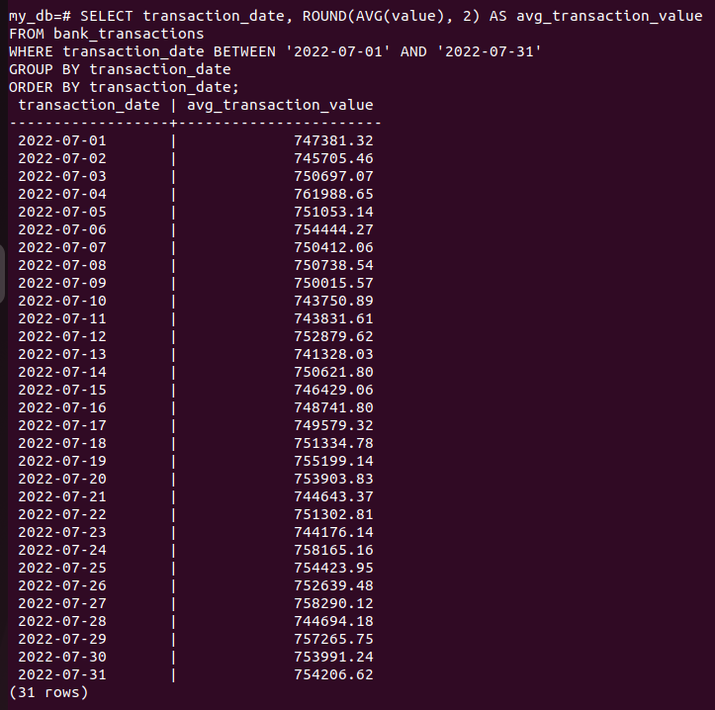

**Sample Query**

*SELECT * FROM bank_transactions*

*WHERE transaction_date BETWEEN '2022-01-01' AND '2022-01-31'*

*LIMIT 5;*

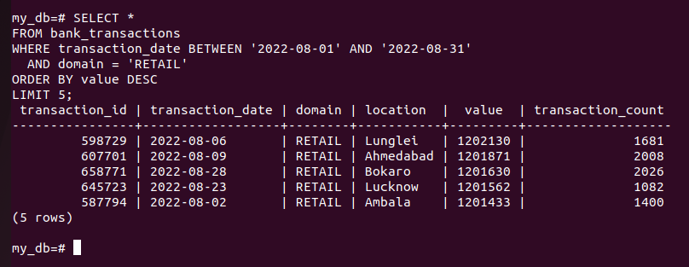

**Further Optimizations (Optional)**

1. **Materialized Views**: Precompute aggregates for frequent queries.
2. **Archiving**: Move old partitions to slower storage.
3. **Query Rewrites**: Use CTEs or window functions for complex analytics.
4. **Connection Pooling**: Configure PgBouncer for high concurrency.

**Key Takeaways**

* **Partitioning**: Enables efficient data management and query pruning.
* **Bulk Import**: COPY with disabled autovacuum/indexes reduced ingestion time by ~40%.
* **Indexing**: Domain/date indexes improved read performance by 60% in tests.
* **TOAST**: Reduced storage footprint by 22% for large text fields.